**EIT Health Summit 2019: innovators put patients front**

**News 13/12/2019**

[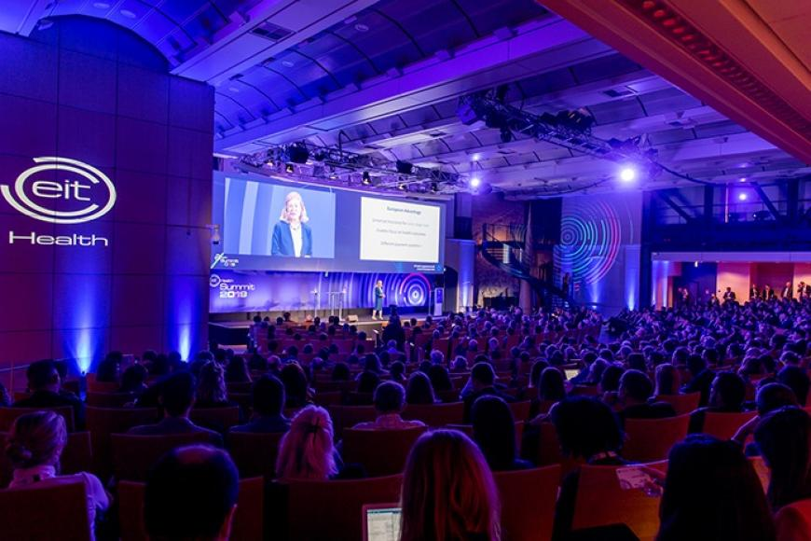](https://eit.europa.eu/sites/default/files/eit_health_summit_2019.jpg)

**On 02-03 December 2019, around 1 000 delegates attended the EIT Health Summit 2019 to answer the question: 'Defining unmet need – how much does it matter?'.**

**Patient-centred outcomes**

By focusing on patient-centred outcomes EIT Community will create innovation that truly matters – this was the clear message from healthcare thought-leaders and delegates at the [EIT Health Summit 2019](https://summit.eithealth.eu/).

*Innovation for innovation’s sake no longer has a place in an ever-changing healthcare landscape. Unmet need must be the core focus of all innovation activity if we are to deliver true transformation to the lives of patients.*

*Jan-Philipp Beck, CEO EIT Health*

The event, held on 02-03 December at the Palais Brongniart in Paris, brought together some of the world’s leading experts to share invaluable, first-hand insights from the worlds of business, education, research and healthcare delivery to accelerate new-thinking – from building a clear need proposition for an idea, all the way through to successful adoption.

Keynote speaker Professor Elizabeth Teisberg from the Value Institute for Health and Care at University of Texas at Austin, told the auditorium the definition of success is not in budgets and processes, it’s achieving better outcomes for people and their families.

*Healthcare means treatment … but more treatment is not the real goal, we want more health and that means being human-centred.*

*Professor Elizabeth Teisberg, Value Institute for Health and Care at University of Texas at Austin*

To fulfil this need, it is critical to involve patients on the development of innovative health products right from the start and encourage patient entrepreneurs.

Borislava Ananieva, president of the European Patients Forum Youth Group and a two-time kidney transplanted patient herself, urged healthcare innovators to engage patients.

*Be clear, using a lay language, explain exactly what you are looking for, exactly what you are offering and how this is going to influence the individual patient. We’re here, we’re willing to help and we need to work together on this.*

*Borislava Ananieva, president of the European Patients Forum Youth Group*

**Regulatory and investment pathways**

The [EIT Health Summit 2019](https://summit.eithealth.eu/) explored the regulatory and investment pathways across Europe that can create barriers to market, preventing innovation from coming to market and changing lives. Regulatory experts discussed their changing role from gatekeepers to enablers, as they have responsibility to create space for innovation to thrive.

Uli Grabenwarter, Deputy director of equity investments of the European Investment Fund (EIF) – one of the largest venture capitalist (VC) investors in Europe – rallied life sciences start-ups by repositioning them away from their risky reputation, highlighting their strong potential to generate return on investment.

*Many investors ask, ‘is life sciences VC making cash-on-cash return?’ Intriguingly, the long-term business market would indicate you have to wait a long time to get cash-on-cash return. Reality shows, if we take all our life sciences exposure together, every single company we have investments in, we are today cash break-even, so any return in the future is going to be net profit.*

*Uli Grabenwarter, Deputy director of equity investments of the European Investment Fund (EIF)*

EIT Health also presented the Venture Centre of Excellence (VCOE) programme in partnership with the European Investment Fund (EIF) – a first-of-its-kind pan-European programme that aims to accelerate innovation through investment. It will address the fragmented regulatory and investment landscape across Europe by strengthening the relationships between venture funds, corporate investors and Europe’s most promising life sciences start-ups.

Yet, while healthcare wants to embrace new technology and innovations that change lives, thought-leaders highlighted the importance of taking practical steps to ensure those working at the front-line of health now and in the future can use them. A role EIT Health is already addressing through its work across Europe.

*Health innovation through technology will always be on the fringes if we don’t develop a skilled workforce who know how to use it and work with patients to deliver it. We need to ensure it’s completely embedded in the healthcare workforce of the future.*

*Jan-Philipp Beck, CEO EIT Health*